SOLAR TRACKER and SUN PATH FINDER
A device that always rotates perpendicular to the rays of the Sun and at the same time records the angles formed by the Sun at the place where the device is set up.

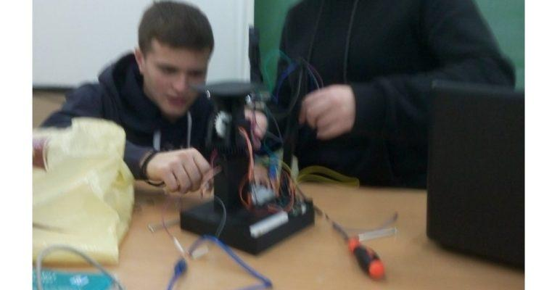
GROUP NAME "HELIATORS": The 1st STEM team that under my guidance after a series of extracurricular laboratory courses built, among other things, the specific device following the guide I have in GITHUB and through it any colleague who wishes to build. For this construction, "HELIATORES" received the 3rd prize in the competition of ELLAK robotics 2020, which the committee evaluated only as a "robotic" device. But I also developed it to be an easy-to-use laboratory tool for astrophysics (measuring the altitude, azimuth angles of the Sun in real time in the schoolyard).
Detecting the "path" of the Sun.
In the age of information we find, a researcher finds on the internet either "diamonds" or "garbage" like nonsense about flat earth. One of the many ways we show children the scientifically correct truth is with experimental devices like the one I present here. But also show the best way to use solar energy with photovoltaic panels.
a.Study of the current
situation in the use of solar energy
The photovoltaic systems-photovoltaic panels that operate in their majority are static, i.e. they do not turn to the sun and thus according to our sources have a loss of at least 20% of energy.
b. Clear definition of
problem - need
But the sun performs best only when it "falls" perpendicular to the panel, so we look for a way for the panel to follow the sun's rays. One way to monitor it is with photosensitive resistors (LDR) which are monitored by the arduino microcontroller and with 2 servo the microcontroller adjusts the panel so that the rays fall vertically.
A FEW WORDS ABOUT THE ADVENTURE OF CONSTRUCTION
The search began with the aim of building a solar tracker such as https://www.instructables.com/id/Building-an-Automatic-Solar-Tracker-With-Arduino-N/.
BUT all these constructions are for indoor space and for demonstration purposes (it is a light tracker) and not for a real solar tracker.
c.Definition of a proposed solution-originality of differentiation
And here I entered the great adventure of building a real solar tracker and as a natural consequence (application of astrophysics) and solar pathfinder- scientific tool for finding the angles that the SUN erases in our area.
And I redesigned our project to cover the angles that the sun erases in our area - a complete study of' the Sun motion can be found on youtube like this video: https://www.youtube.com/watch?v=OR8EQ0DWpPw&t=49s
EXPLANATION OF THE GROUP constructed under the guidance MY PROJECT, VIDEO

LINK: https://www.youtube.com/watch?v=emRvdH7JC2I&t=79s SOLAR PATH FINDER AND SOLAR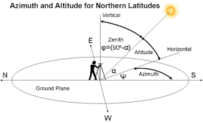
There are two ways of determining the azimuth.The first is from geographic north to east and the second from south to east +angle see the picture above , - angle to the other direction.

LABORATORY PROCEDURE
1. EXPLANATION-LESSON IN THE CLASSROOM WITH:Power point presentation , discussion and video
2. Using a device in the courtyard and exporting a graph * such as:

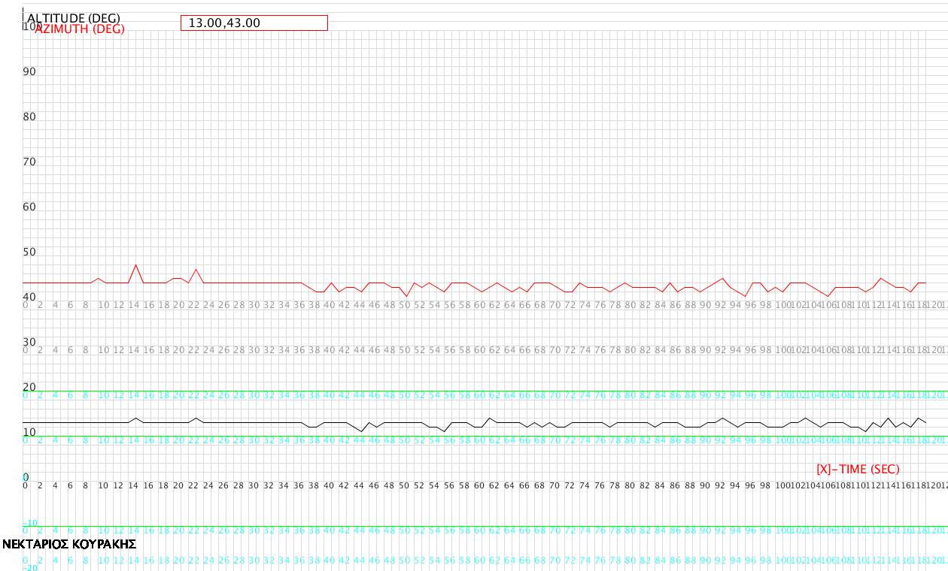
22-12-2020 09:00 UTC + 2
* I have created a graphical environment through processing ide on a pc or laptop for live display of the corners of the Sun - which it receives via Bluetooth from the device - and saves the results. We measure the azimuth here in the 2nd way so in order to control the result we do the operation e.g. here 180⁰ -43⁰ = 137⁰ .
Web page astrophysics given by the angles of the sun depending on the area to compare results and find the percentage deviation from the graph we find.
We repeat the experiment 1 month later at the same hour, find different results and talk about this fact in class.
Detailed instructions for using the device on GITHUB.
CONSTRUCTION: (from here to the penultimate page is the construction method, so in a first reading it can be omitted)
Materials (final report):
1.arduino uno (https://grobotronics.com/funduino-uno-rev3-arduino-uno-compatible.html) = € 11.90
2. 4 ldr (https://grobotronics.com/photo-resistor-ldr-5mm.html)=4*0,20=$ 0,80
3. * 2 servo (link : https://grobotronics.com/servo-small-5kg.cm-metal-gears-with-analog-feedback-feetech-fs9225m.html
https://grobotronics.com/analog-feedback-micro-servo-plastic-gear.html
) = € 9.90 + € 12.20 = € 21.10
4.wires (https://grobotronics.com/jumper-wires-15cm-female-to-male-pack-of-10.html AND https://grobotronics.com/jumper-wires-15cm-male-to-male-pack-of-10.html )=
=2*$1.80=$ 3,30
5..breadboard (https://grobotronics.com/breadboard-400-tie-point-white-half-size.html) =
= € 3.20
6.Bluetooth Module for Arduino - HC05 (https://grobotronics.com/bluetooth-module-for-arduino-hc05.html) = € 6.80
7. 4 resistors 1kohm (https://grobotronics.com/carbon-1-4w-5-1kohm.html) = € 0,04
8.servo arm (https://grobotronics.com/servo-arm-double-5cm-horn-spline-25t.html) = € 1.90
9. 4mm screw with length 9cm = € 0.10
10 .Plastic gears from 3D printer of the exhibitions (STL ARCHIVES INCLUDED AS ST1, ST2, ..)
INDICATIVE TOTAL = € 49,00
We tested the solar panel outdoors-https: //grobotronics.com-3solar-pan w-165x135mm.html-on our solar tracker, which easily charged a smartphone.
SOFTWARE
1) ARDUINO IDE
2) TINKERCAD-ONLINE 3D DESIGNER https://www.tinkercad.com/
3) PROCESSING IDE
TOOLS
1) Screwdriver
2) Paper cutter for removing imperfections from 3D components.
FINAL PROBLEM DESCRIPTION Our age requires large energy reserves, so an efficient photovoltaic panel that follows our sun shows the way to the manufacturers of photovoltaic systems.Especially when our project records the angles created by the sun on the mainland in Chania and thus shows per day and time the appropriate angle that the f-panel must have for maximum efficiency. A scientific work of this kind trains future scientists in the STEM-Positive Science-Robotics interdisciplinary framework. Following the path of thesun.Following the previous answer, our idea is to build a solar tracker that will adjust our photovoltaic panel perpendicular to the sun's rays to have maximum efficiency and at the same time will record these angles. We will use 4 ldr photoresistors the light sensors that depending on the light they receive will command our panel to rotate to the correct position - 2 servos to execute the above commands and will also betilt sensors *to record these angles. Of course arduino which is the brain of our construction. 3D printed parts will give stability and efficiency to our construction.
* (With 3D components we made two identical constructions. The first-link https://github.com/nektarios25ma/Solar-tracker/tree/master3- uses an independent 9-axis MEMS sensor with extra MCU to give the gradients and the secondmost frugalwith sensors slopes themselves servo * additionally has the advantage that it can track-recordallangles deletes the sun during the time for it hasre-designedall 3D components from our group. Cj this is why we chose to present it as the main construction)
CONSTRUCTION-Here as in github -in more detail- I describe the way it is constructed.
You will find the designed 3d components from our team as stl files on github. The servo that is in our list "clicks" exactly on the above components.
The servo: https://grobotronics.com/servo-small-5kg.cm-metal-gears-with-analog-feedback-feetech-fs9225m.html
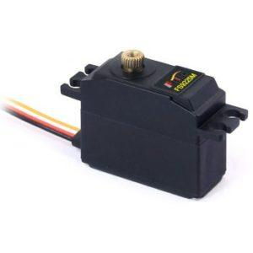
"clicks" on the 3d componentbase.stl (or stl 1) -in slot you see,
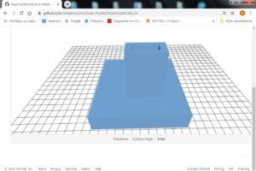
Put the servo arm on the servo (https://grobotronics.com/servo-arm-double-5cm-horn-spline-25t.html)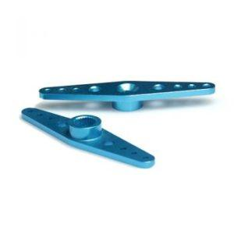.
AS IN FIGURE 1
FIGURE 1:
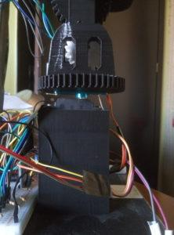
On the servo arm screw the 3d componentpanel-mount.stl (or stl2)
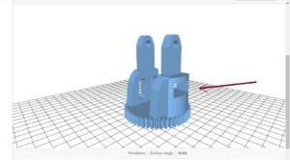
and place the 2nd servo (where the arrow shows)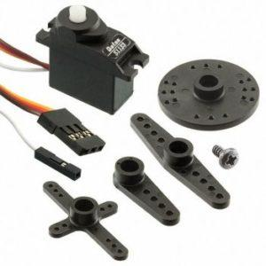
in the appropriate opening ofpanel-mount.stl,as in picture 2 :
Figure 2
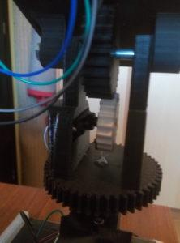
In the 2nd servo we screw theVertical_Servo_Gear.stl (or stl5, the white in the picture2)
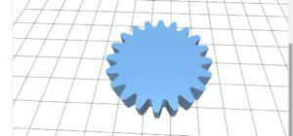
as in the picture 2.
In thePanel Bracket.stl (or stl4) we
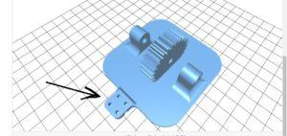
place theLDR DIVIDER HIGH.stl (or stl3) where the arrow shows (has a slot to accept it and let it not appear in the picture above).
LDR DIVIDER HIGH.stl:
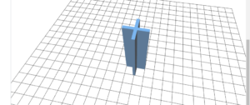
Finally with the appropriate screw 4mm with a length of 9cm and the corresponding nuts we place thePanel Bracket.stl as in picture 2.
The connection must be done as(circuit)
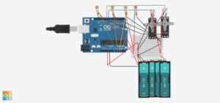
And the bluetooth hc-05-connection we quote it in another image because the tinkercad-circuit from which we made the above image does not have a bluetooth element
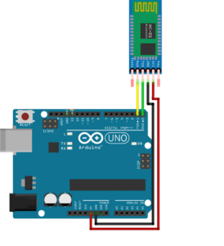
ALL THE FILES ARE LOCATED ON GITHUB WITH GREATER RESOLUTION.
Then we had to calibrate the servo to measure the right angle and in this laborious process the 2nd link helped (see the file on github -calibration processthat explains in detail).
The voltage divider shown on the circuit located on github (and above) finally worked well outdoors with 500 ohm resistors (4 resistors). Depending on the behavior of the ldr we choose (experimentally) corresponding resistors so that outdoors they work satisfactorily .
BIBLIOGRAPHY REFERENCES
- https://en.wikipedia.org/wiki/Sun_path2)https://en.wikipedia.org/wiki/Position_of_the_Sun3)https://www.youtube.com/watch?v=lJVEubm9Ja84)https : //www.instructables.com/id/Arduino-Solar-Tracker/
- LINK THAT HELPED IN THE CALIBRATION SERVO *: https://dronebotworkshop.com/analog-feedback-servo-motor/
Ο ΒΑΣΙΚΟΣ ΑΛΓΩΣΜ HIS OPERATING LOGIC IS DESCRIBED BELOW
ALGORITHM-FLOWCHART
(click-click on) https://openedtech.ellak.gr/wp-content/uploads/sites/31/2019/11/%CE%91%CE%9B%CE%93%CE%9F%CE%A1%CE%99%CE % 98% CE% 9C% CE% 9F% CE% A3-FLOWCHART.pdf Utilities were
also used to calibrate servo *.
AT THE LINK * FOLLOWING IS MOUNTEDALL FILES THAT ARE NECESSARYFOR THE UNDERSTANDING AND CONSTRUCTION similar EGCHEIRIMATOSLINK: https://github.com/nektarios25ma/Solar-tracker
(branchmaster)

